Master’s thesis technical writing recommendations
Recommendations for the students

Sire-Sárá Sápmelaš
Sámi language and litterature master’s thesis, 2019

Abstract in English
You need to write a half-a-page or a page long abstract at the beginning of the thesis. The abstract usually presents the topic or the research problems, the theoretical background, the methodology and the results of the research. The style of the abstract is “Heading without number”. There is more information about styles in Chapter 2.

Abstract in Sámi
You can also choose to write a summary in Sámi, about the length of half a page (or a page), which will show the Sámi title of the thesis. The Sámi abstract can be shorter than the English one, and it is written on its own page after the English abstract. The abstract in Sámi is not mandatory. The style is “Heading” (without number)~.

Foreword
It is not common to have a foreword in a master’s thesis, but if you want to write one, it should be short and placed before the table of contents. The style of the foreword is “Heading without number”. If there is no foreword, the table of contents will come on the page three.

Contents
Abstract in English 1
Abstract in Sámi 2
Foreword 3
Contents 5
1 Introduction 7
2 Overall layout 8
2.1 Creating a table of contents 8
2.2 Text formatting 8
2.3 Tables and figures 10
2.4 Appendices 11
3 Referencing 12
3.1 Referencing in the text 12
3.2 Creating a list of references 13
3.3 Electronic sources 14
4 Language 15
5 Conclusion 16
References 17

Introduction
The purpose of this text is to explain and show how to create a layout and format a master’s thesis for the Sámi University of Applied Sciences. The first part presents guidelines for writing an English and Sámi summary and a foreword. It also shows the layout and the format the table of contents should have. This part is followed by guidelines for the overall layout of the text (in Chapter 2), for referencing (in Chapter 3), and for the use of language (in Chapter 4).
The objective of the introduction is to inform readers about the thesis and get them interested in reading it. We also recommend that you tell about the main contents of the following chapters in the introduction, as is done here.

Overall layout
At the beginning of the thesis, you must have the abstracts and a table of contents. It is not common to have a foreword in a master’s thesis, but if you want to write one, it is placed on its own page after the summaries and before the table of contents. The length of the thesis is determined in the curriculum.

Creating a table of contents
The table of contents can be created by opening the References Tab and then choosing “Table of Contents”. The table of contents is changed automatically when you click “Update Table of Contents” in the left top corner of the table. More information is available at: https://support.microsoft.com/en-gb/office/format-or-customize-a-table-of-contents-9d85eb9c-0b55-4795-8abb-a49885b3a58d?ui=en-us&rs=en-gb&ad=gb:

Text formatting
The text must be divided into chapters, and the headings of the chapters and subchapters must be understandable and systematic. It is common to give numbers to the chapters. The spacing must be 1.5 and the font size 12.
The main chapters and the list of references all begin on a new page. If there are footnotes, they are placed at the bottom of the page, not at the end of the text, and they must be numbered. You should use as few footnotes as possible. If you plan to write something in the footnote that cannot be explained in the main text, you should consider leaving the footnote out.
Linguistic elements are written in italics (for example, the word river, the clause A river is a natural flowing watercourse). Italics can also be used for introducing new terms when they appear in the text for the first time. Do not use underlining.

Sometimes you will need to use a quotation: “There are about a dozen non-finite verb forms in North Saami” (Ylikoski 2009: 14). If the quotation is longer than a few lines, it is practical to separate it from the main text, as is done in the following example. When the quotation is separated this way, you neither mark it with italics nor with quotation marks:
[...] indigenous knowledge comprises all knowledge that belongs to a certain people and concerns a certain environment (the varieties of academic, technical, ecological, spiritual, and cultural knowledge).

The use of styles makes it easier to fulfil the formal requirements of the thesis. Each style has its own font size and emphasis styles such as italics, bold, etc. You do not need to use various styles if you do not want, but if you do, it is important to use them throughout the document. If you do not set styles, the possible changes must be made manually. For this document, we have set the following styles.
- Clear all; removes all styles in the document and changes the whole body of the text into normal (Times New Roman 12 pt)
- Title, the main title of the thesis, used on the cover page
- Title, the subtitle of the thesis, used on the cover page
- Title, author, used on the cover page
- Title, the name of the master’s programme and the conferral year, used on the cover page
- Footnote reference, used when adding a footnote to the text
- Footnote text, used for writing the footnote
- Informants, material, bibliography, other sources, used in the list of references under these headings
- Indent paragraph, used for long quotations
- Normal, used for the body of the text
- Normal, first line indented, used when the first line of a paragraph is indented
- Heading without number, used for the headings of the abstracts, foreword, table of contents and list of references
- Headings 1, 2, 3, 4, 5, 6; used for different levels of headings. Bajilčála 1 lea bajimus ja adnojuvvo váldokapihttaliid ja gáldolisttu bajilčállagiin
- Numbered figures in brackets, used in example sentences
- Numbered figures for sections
- Emphasised text, italics
- Bold as emphasis style
- Caption, used under photographs and figures

Note that, under “Styles”, there are also font types that must not be used in master’s theses, e.g. “Title master’s thesis p. 3”.

Tables and figures
This subchapter deals with the use of figures, photographs and tables. The first example is Figure 1.

Figure 1. Distribution of events in four municipalities.

Tables and figures are numbered and given names, as has been done with Figure 1 here. The terms figure, table and photograph and their numbers are written in italics. You write the name of the photographer at the end of the caption (see Photograph 1), but remember to inspect the copyrights of the photographs before submitting the thesis for evaluation.

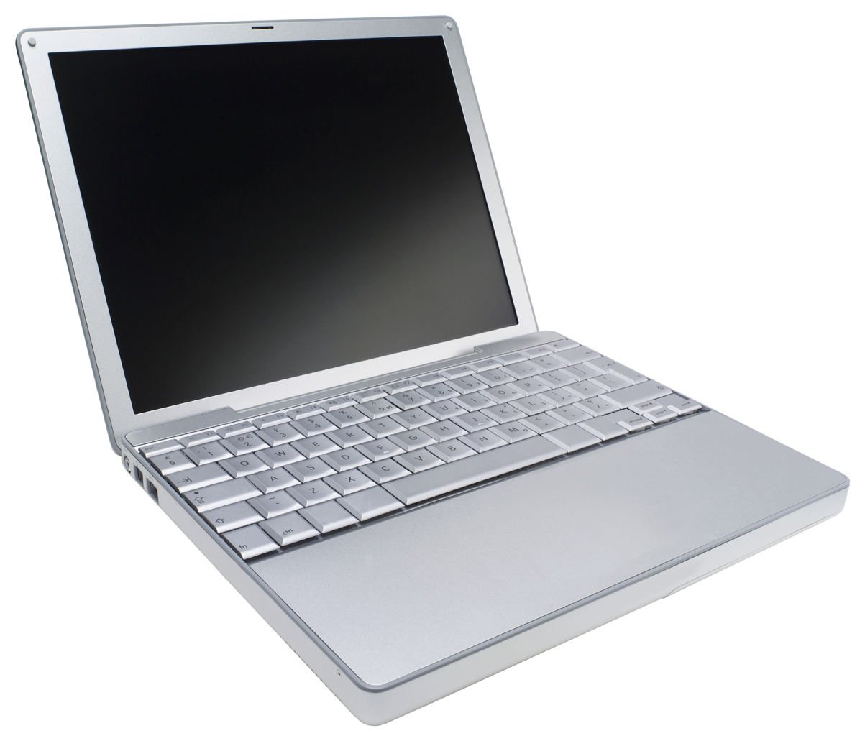
Photograph 1. A computer that can be used for writing academic texts. Photograph: Ole Olsen.
Tables can be a practical way of presenting information. Each table must have a number and a name, as in Table 1. It is important to explain in the text what the table shows.

Type of mistake | Number of mistake
Spelled as one word | 57 | 18,3 %
Spelled as two words | 255 | 81,7 %
Total | 312 | 100 %
Table 1. Spelling mistakes with compounds in the whole research material.

You can read about creating tables here: https://support.microsoft.com/en-gb/office/format-a-table-e6e77bc6-1f4e-467e-b818-2e2acc488006?ui=en-us&rs=en-gb&ad=gb.

Appendices
If the thesis has appendices, they come after the list of references. As appendices, you can have maps, tables and other information that cannot fit in the text or you do not wish to have there. The appendices must be numbered but left without page numbers.

Referencing
When writing academic text, you must give your sources. This must be done precisely both in the text and the list of references. Before you submit your thesis for evaluation, you must check that all the references you have in the text are also included in the list of references. Similarly, all the sources in the list of references must be mentioned in the main text.

Referencing in the text
The reference is given in detail, for example, as follows: (Aikio 1992: 62), or (Aikio 1992: 62–64, 71). If the thesis mentions several authors with the same family name, you must also give the first letter of the author in the reference: (O. H. Magga 1994; T. Magga 2003). If the source has two authors, the symbol & is put between the two: (Gries & Divjak 2009). If the source has more than two authors, you present only the first author as follows: (Bals et al. 2010). You can also refer to an article in a periodical in the following way: (Ávvir 25.11.2011), and to oral sources in this way: (Sammal¬lahti [2005a]).
The reference is given within the sentence when it only refers to one sentence, like in the following example:
Norwegian authorities began to see the Coast Sámi seasonal dwelling pattern, changing of dwelling sites and the use of many haymaking grounds as a problem, which they started to control and restrict through administrative measures of land use in the 1800s (Jernsletten, R. 1986; Mákká Regnor 2003: 40–41).

In the above example, the reference is put in brackets before the full stop that ends the sentence.
If the reference refers to more than one sentence, you give it after the full stop. Note that in such referencing, you also put a full stop inside the brackets:
Meronymy can be systematisised using segments or systematic parts. Segmental parts are parts that are tied together and can be seen (if visible), for example, the segmental parts of a body are head, leg, arm, etc. Systematic parts, in turn, are parts that can be intertwined with all the parts, for example, veins, tendons and muscles. (Cruse 1986: 169.)

Often, it is practical to put the reference right within the text, as is done in the following sentence.
According to Sandvik (1993: 280), the amtman, or bailiff, began to require in the 1860s that places or areas should also have official names in Norwegian, in addition to Sámi or Finnish.
If you use a later edition of a book as your source, you write the year of the first edition in brackets after the publishing year of the edition you have used: (Nielsen 1979 (1926–1929): 278). When written like this, the author of the thesis has used as their source a book that was printed in 1979, but the first edition of which was published in 1926–1929.
If the first version of the source was not a printed version, the year of the first version is written in square brackets after the year like this: (Fellman 1906 [1844]: 21). In this case, Fellman’s manuscript was completed in 1844, but not published until 1906, and the author of the thesis has used the 1906 book as their source.

Creating a list of references
You must include the data on the informants, research material, literature and oral sources that you have used when writing your thesis in a list of references. The reference list of this text shows examples of how to present this information. Here, you get advice on how to create the references for literature.
First you write the name of the author. If the source has more than one author, their names are written as follows: Family name, First name & Family Name, First name & Family name, First name (see Bals et al. 2010). Then you write the year of publication. After the year, you write a colon.
The title of a book is written in italics. The title of an article or a chapter from a book is written in normal type, while the title of the main source comes in italics. Put a dash (–) between the article or chapter, and the main source. The titles of periodicals are written in italics (e.g. Norsk medietidsskrift 2/2005), while the titles of article series are written in normal style (e.g. Dieđut 3/2004).
The name of the editor of an article collection is written like this: First name Family name, or, if there are several editors, like this: First name Family name & First name Family name & First name Family name. Before the name of the editor, you put a dash, and then comes the abbreviation for the word editor in brackets like this: (ed.) (see Bull 2004).
You also need to include the place of publication and the publisher (not the printing house). The data on the sources are taken from the colophon page (not the cover). You can use square brackets if the information that is otherwise clear cannot be found in the source material, for example when the place of publication is not given in the book: [Guovdageaidnu]: Sámi Instituhtta. We recommend that you use abbreviations for long titles of books – e.g. SNSO – in the thesis. When doing so, you must also explain the abbreviation in the list of references by showing the whole title (see SNSO in the list of references in this text). It is very important that you write the sources accurately, so that readers can find them.

Electronic sources
Electronic reference sources can vary, but electronic texts also have authors, titles and dates of publication. Furthermore, there are also sources that are available both in an electronic and a printed form. Furthermore, many old books and periodicals are easiest to find in an electronic form, so it is often a good idea to give the readers the electronic address of the source.
Electronic references are given in the thesis as clearly and precisely as printed references. You must not have direct internet addresses in the main text, but write instead the authors’ names, years of publication and also page numbers, if possible (e.g. Rask 1832: 30–33; Koponen et al. 2010: 3–4; Morottaja 2011).
Electronic references are marked in the thesis as clearly and precisely as printed references. You must not have direct internet addresses in the main text, but write instead the authors’ names, years of publication and also page numbers, if possible (e.g. Rask 1832: 30–33; Koponen et al. 2010: 3–4; Morottaja 2011).
Electronic sources are given in the list of references as follows: author’s name or authors’ names, year of publication, title of the article, electronic address. Give the electronic address as the entire URL address, and, after it, put the date of reading the source in normal brackets, for example <http://www.perepis2002.ru> (12.12.2006). See the list of references for more examples and details on how to give sources.

Language
The text of the master's thesis must be linguistically clear, comprehensible, and finalized. Please be aware that there should not be any linguistic errors in the master’s thesis and that proofreading must be done before submission.

Conclusion
This text explains and shows how to create and format a master’s thesis. You need to follow the guidelines precisely so that readers can easily read the thesis and understand its content. It is important to remember that readers prefer to read texts that are in good condition both in terms of their form and language. This allows them to concentrate on the content of the text.

References
Informants
AR = Anders Ranta, Giron, r. 1934
BS = Biret Säkkinen, Unjárga, r. 1978
HH = Hans Hanssen, Heahttá, r. 2001
MK = Maija Karlsson, Olmmáivággi, r. 1947

Material
EMV = Vars, Ellen Marie 1996: Ja idja ii galgga šat leat. Álaheadju: Forlaget de tre.
HAG = Guttorm, Hans Aslak 1982: Golgadeamen. Deatnu: Jår’galæd’dji.
JÁV = Vest, Jovnna-Ánde 1988: Čáhcegáddái nohká boazobálggis. Kárášjohka: Davvi Media.
RPL = Paadar-Leivo, Rauna 1994: Goalsenjárga. Kárášjohka: Davvi Girji.

Bibliography
Aikio, Samuli 1992: Olbmot ovdal min. Sámiid historjá 1700-logu rádjái. Ohcejohka: Girjegiisá.
Antonsen, Lene 2007: Giella buolvvas bulvii. Gáivuona sámegiela morfologiija guorahallan. Master’s thesis in the Sámi language, Gielladiehtaga instituhtta, Humanisttalaš fakultehta, Romssa Universitehta. <http://munin.uit. no/bitstream/handle/10037/1210/Giella_buolvvas_bulvii.pdf> (19.4.2013).
Ávvir 25.11.2011 = Vars, Nils Johan 2011: Sámi joatkkaskuvlla matematihkkaášši: – Dušše álgováttut. – Ávvir 25.11.2011. <http: //www. avvir. no/vivvo_general/1802.html> (19.4. 2013).
Bals, Margrethe & Turi, Anne Lene & Skre, Ingunn & Kvernmo, Siv 2010: Internalization symptoms, perceived discrimination, and ethnic identity in indigenous Sami and non-Sami youth in Arctic Norway. – Ethnicity & Health 15 (2): 165–179. doi: 10.1080/13557851003615545
Bull, Kirsti Strøm 2004: Saami customary law and the proposals of the Saami Rights Committee. – Michael Jones & Audhild Schanche (eds.), Landscape, Law and Customary Rights. Dieđut 3/2004. Guovdageaidnu: Sámi Instituhtta. 161–171.
Denzin, Norman K. & Lincoln, Yvonna S. 2000. Introduction: The discipline and practice of qualitative research. – Norman K. Denzin & Yvonna S. Lincoln (Eds.), The Sage handbook of qualitative research (4th ed.). Thousand Oaks, CA: Sage. 1–20.
Freeman, R. Edward 2010. Strategic management: A stakeholder approach. New York: Cambridge University Press.
Gries, Stefan Th. & Divjak, Dagmar 2009: Behavioral profiles: a corpus-based approach towards cognitive semantic analysis. – Vyvyan Evans & Stéphanie Pourcel (eds.), New Directions in Cognitive Linguistics. Amsterdam: John Benjamins. 57–75.
Guttorm, Gunvor 2004: Duodji, dáidaga suoivva dáiddasuokkardeamis? – Sámi dieđalaš áigečála 1/2004: 201–213.
Itkonen, Erkki 1966a: Esiintyykö s-latiivi permiläisissä kielissä? – Virittäjä 70: 273–280.
Itkonen, Erkki 1966b: Kieli ja sen tutkimus. Helsinki: WSOY.
Jåhkåmåhke kommuvnna 2009: Mánáj- ja Åhpadusplána. Jåhkåmåhke kommuvnna 2008–2011. <http://www.jokkmokk.se/Filer/Utvecklingsenheten/Minoritetsspråk/skolplan_2008-2011_lulesamiska.pdf> (21.6.2010).
Kalstad, Johan Klemet Hætta 1999: Reindriftspolitikk og samisk kultur – en uløselig konflikt? En studie av reindriftstilpasninger og moderne reindriftspolitikk. Dieđut 2/1999. Guovdageaidnu: Sámi Instituhtta.
Kalstad, Johan Klemet Hætta 2012: Beassášmárkanat Guovdageainnus ja Áillohaš rohkki. – Sámis 11: 30–35.
Kappfjell, Lena 2012: Kunnskapsbegrepet i urfolksdiskursen. Kultuvrra ja girjjálašvuođa instituhtta, Humaniora, servodatdiehtaga ja oahpaheaddjeoahpu fakultehta, Romssa universitehta. [Manuscript.]
Koponen, Eino & Moshnikoff, Jouni & Moshnikoff, Satu 2010: Sää´mǩiõll, ä´rbbǩiõll. Kotimaisten kielten tutkimuskeskuksen verkkojulkaisuja 14. Helsinki: Kotimaisten kielten tutkimuskeskus. <http://scripta.kotus.fi/www/verkkojulkaisut/julk14/> (31.5.2011).
Kuokkanen, Rauna 2009: Boaris dego eana. Eamiálbmogiid diehtu, filosofiijat ja dutkan. SÁMIacademica 2. Karasjok: ČálliidLágádus.
Kåven, Brita & Jernsletten, Johan & Nordal, Ingrid & Eira, John Henrik & Solbakk, Aage 2011 (1995): Sámi-dáru sátnegirji. Samisk-norsk ordbok. Kárášjohka: Davvi Girji.
Longman, Mary 2014: Aboriginography A New Decolonized Aboriginal Meth[1]odology. – Gunvor Guttorm & Seija Risten Somby (ed.), Duodji 2012 Riikkaidgaskasaš sámiid ja eará eamiálbmogiid duodje-, dáidda- ja hábmen[1]konferánsa. Dieđut 3/2014. Guovdageaidnu: Sámi allaskuvla. 15–30.
Magga, Ole Henrik 1985: Davvisámegiela čállinvuogi gielalaš vuođđu. – Maj-Lis Skaltje (ed.), Giella: dutkan, dikšun ja oahpaheapmi. Dieđut 2. [Guovdageaidnu]: Sámi Instituhtta. 42–67.
Magga, Sigga-Marja 2014: Geahčastagat, olggušteapmi ja albma duoji gáibádus – duodjekontrolla duojáriid vásáhussan. – Sámi dieđalaš áigečála 2/2014: 29–46.
Magga, Tuomas 2004: Dárogiela preposišuvdnaráhkadusaid jorgaleapmi. – Sámi dieđalaš áigečála 1/2004: 43–53.
Morottaja, Petter 2011: Marko Jouste nägättâlâi anarâš liivđijn. – Kierâš 3/2011: 5. <http://nettisaje.wikispaces.com/file/view/kieras2011_03.pdf> (14.1.2012).
Moshagen, Sjur Nørstebø 2008: A language technology test bench – automatized testing in the Divvun project. – Rickard Domeij & Sofie Johansson Kokkinakis & Ola Knutsson & Sylvana Sofkova (eds.), Proceedings of the Workshop on NLP for Reading and Writing – Resources, Algorithms and Tools. NEALT Proceeding Series 3. Stockholm: SLTC. 19¬–21.
Nickel, Klaus Peter & Sammallahti, Pekka 2011: Nordsamisk grammatikk. Karasjok: Davvi Girji.
Nielsen, Konrad 1979 (1926–1929): Lærebok i lappisk (samisk). Oslo: Universitetsforlaget.
Nielsen, Konrad 1979 (1932–1962): Lappisk (samisk) ordbok grunnet på dialektene i Polmak, Karasjok og Kautokeino III: N–Æ. Oslo: Universitets¬forlaget.
Det Norske Nobelinstituttet 2013: Alfred Nobel. Oppfinner, forretningsmann, fredsvenn. <http://nobelpeaceprize.org/nb_NO/alfred-nobel/> (24.6.2013).
Rask, Rasmus 1832: Ræsonneret lappisk Sproglære efter den Sprogart, som bruges af Fjældlapperne i Porsangerfjorden i Finmarken. En Omarbejdelse af Prof. Knud Leems Lappiske grammatica. København: J. H. Schubothes Boghandling. <http://books.google.com/books?id=-aMRAAAAIAAJ> (29.11.2011).
Sammallahti, Pekka 1989: Sámi-suoma sátnegirji. Saamelais-suomalainen sanakirja. Ohcejohka: Jorgaleaddji.
Sandven, Jostein 2004: Vandring på samiske ferdselsårer som tema på Finnmarks[1]vidda TechneSerien B: 13/2004. Notodden: Høgskolen i Telemark. 138–155.
Sims, Nate 2013: Vowel Harmony in Qiang: An Optimality Theoretic Account. <http://roa.rutgers.edu/article/view/1269> (10.6.2013). [Manuscript.]
Smith, Graham Hingangaroa 2003: Kaupapa Maori Theory: Theoretic Indigenous Transformation of Educating & Schooling. Kaupapa Maori Symposium. NZARE / AARE Joint Conference, Auckland, N.Z., December 2003. <http://publications.aare.edu.au/03pap/pih03342.pdf> (23.3.2012).
SNSO 2000 = Stor norsk-samisk ordbok. Dáru-sámi sátnegirji 2000. Kárášjohka: Davvi Girji.
Stordahl, Vigdis 1995: Manne lea nu jaskat – sámi váilevaš servodatságastallama birra. – Harald Gaski & John Trygve Solbakk (eds.), Essayčoakkáldat 2: cafe Boddu. Kárášjohka: Davvi Girji. 128–136.
Turi, Johan 2010 (1910): Muitalus sámiid birra. SÁMIacademica 3. Karasjok: Čálliid¬Lágádus.
Valkeapää, Nils-Aslak (ed.) 1994: Boares nauti Johan Thuri. Guovdageaidnu: DAT.
Yakovleva, Natalia 2011: Oil pipeline construction in Eastern Siberia: Implications for
indigenous people. Geoforum 42: 708–719.

Other sources
Sammallahti, Pekka [2005a]: Lecture on Skolt Sámi language at the University of Oulu 6.9. 2005.
Sammallahti, Pekka [2005b]: Oral information at the doctoral school of Giellagas Institute, University of Oulu 21.11.2005.

This is an example of what the footnote should look like. The next footnote will be number 2, even if it is on the next page.
The style “Footnote” is used for the text in the footnote

